**ROBOCOP IBD System Specification (Type A)**

1. **Scope**

In Operation Iraqi Freedom (OIF) and Operation Enduring Freedom (OEF) there are over 200,000 soldiers supporting the fight and hundreds of men and women have lost their lives in base attacks. In the early 1990’s the United States Army divested from the previous process of base camp erection and support by removing the MOS for basing and stopped training for the set up of base camps. The Army had decided to become a mobile, expeditionary Army and rely on what troops could carry and move. However, we are now facing different threats, guerrilla tactics, terror and counter insurgency. The mobile, expeditionary base camps are not designed to handle all the threats seen by today’s warfare. To date, “no systems or processes treat the base camps as an integrated system or is applicable to all bases across locations” and environments.

The Integrated Base Defense System is a system designed to protect small FOBs in all terrain types. The system will mitigate the external defense issues within small camps, reduce causalities, increase mission performance and protect the Force within the AOR and across the full spectrum of operations from direct and indirect threats with an effective, tailorable, supportable, logistically feasible, integrated, and rapidly deployable protection system. The system will be operable in all weather, all visibility, all terrain with independence from utility infrastructure.

The system will account for a maximum attack of 25-150 enemy troops at a time, will not address issues Inside the wire is considered “safe” so will do address breach issues or “insider” threats, and will not address CBRN, non-lethal or heavy artillery/tanks.

Electronic Protection is the responsibility of the C3 community within the Contingency Base effort, however will address specific interfaces and necessary equipment for protecting defense systems. The system will not protect against sub-terrain threats or environmental threats such as hurricane, earthquake, flooding etc. are not included in base defense.

1. **Applicable Documents**
   1. TRADOC PAM 525-7-7
   2. MIL-STD-810A
   3. MIL-STD-1412
   4. Contingency Basing Functional Decomposition
   5. JP 1-02
   6. Preliminary System Requirements
2. **Requirements**
   1. **System Definition**
      1. **General Description**

The Integrated Base Defense System is a system designed to protect small FOBs in all terrain types. The system will mitigate the external defense issues within small camps, reduce causalities, increase mission performance and protect the Force within the AOR and across the full spectrum of operations from direct and indirect threats with an effective, tailorable, supportable, logistically feasible, integrated, and rapidly deployable protection system. The system will be operable in all weather, all visibility, all terrain with independence from utility infrastructure.

* + 1. **Operational Requirements**
       1. The system shall protect US and allied personnel and their equipment at small forward operating bases. That includes “suicide” attacks, but chem-bio and nuclear defense are outside the scope of this initial version. Additionally, non-lethal deterrence will not be considered in the first version, but may be added in later increments.
       2. The System shall operate in all weather and visibility conditions in which an enemy could employ direct or indirect fires.
       3. Lower-level functions should be automated, but the System should also provide a means for human over-rides. Unmanned sensor and weapons systems shall be used where appropriate.
       4. Network-centric principles and open systems architectures will be followed to the maximum extent achievable in order to achieve complete Joint interoperability.
       5. The System shall be independent of the utility infrastructure normally found at larger bases. It shall be transported and configured by combat or combat support teams of not more than 10 personnel. It should be tailorable for different terrain and operation near an urban environment.
       6. The proposed system shall be constructed and operational within 18 months of contract award, and the operational life cycle for the bridge shall be 6-12 months
       7. The System shall exhibit the following reliability, maintainability and supportability parameters:
          1. Ao = 0.90
          2. MTBF = 750 hours
          3. Training strategy should incorporate traditional school-house training, but emphasize CD- or web-based delivery to users and maintainers in the field.
          4. Preventive and corrective maintenance is expected to follow a traditional O-level, I-level and D-level paradigm. Other approaches will be considered if more cost-effective. Parts support should emphasize sense-and-respond logistics. Remote trouble-shooting and corrective action is also preferred.
          5. Minimize contractors in the field
          6. Display graceful degradation
          7. Enable plug & fight interoperability
       8. Monitor the AOR to detect the full range of air and land activities to maintain real time situational awareness, including sense, identify, locate and track activities.
       9. Enable the evaluation, integration, interpretation and analysis of data and information about the OE in order to provide real time understanding and provide the necessary situational awareness for decision making.
       10. Issue early warnings by directing the relevant information to the right person at the right time about incoming threats, potential threats and hazards.
       11. Enable commander decision making process by transferring pertinent information within XX seconds to enable decision.
       12. Enable dissemination of analyzed information
       13. The system shall execute fires to defend personnel, equipment and facilities from hostile actions and threats identified in section VI.
       14. The system shall control breaches in the perimeter to establish egress and ingress for personnel and vehicles.
    2. **Maintenance Concept**

Preventive and corrective maintenance is expected to follow a traditional O-level, I-level and D-level paradigm. Other approaches will be considered if more cost-effective. Parts support should emphasize sense-and-respond logistics. Remote trouble-shooting and corrective action is also preferred.

* + 1. **Functional Analysis and System Definition**

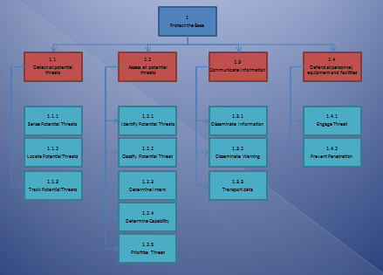

* + 1. **Allocation of Requirements**

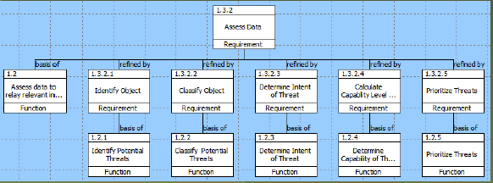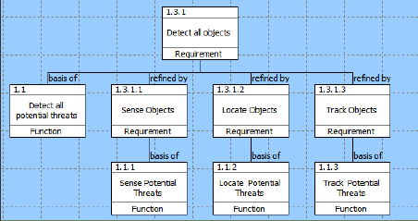

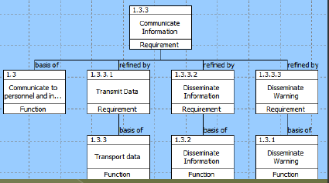

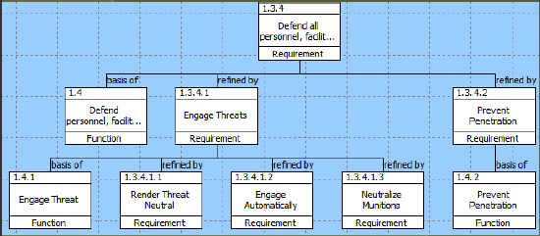

* + 1. Functional Interface and Criteria
       1. The IBDS shall integrate with current C4ISR suite
       2. The IBDS shall integrate with current stand-alone UHF/VHF radio systems
       3. The IBDS shall interface with existing sensor systems
       4. The IBDS shall accept power and utilities from existing base supplies
       5. The IBDS shall interface with current protection systems on larger bases.
       6. The IBDS shall interface with system user in accordance with the HSI Mil Standards.
  1. System Characteristics
     1. Performance Characteristics
        1. Detect Potential Threat

The IBDS shall be capable of detecting all potential threats in the air and on the land.

* + - * 1. Sense Potential Threat

The IBDS shall distinguish a XXX sized object through variations, changes or disturbances in and across the full spectrum including audio, visual IR, UHF, VHF, Microwave; and chemical detection from 500m (T), 1500m (O). (See Classified Annex)

* + - * 1. Locate Potential Threat

The IBDS shall determine the relative location of a stationary object by generating the coordinates of a XXX sized object in terms of azimuth, elevation and distance with a 90%(T), 95%(O) accuracy. (See Classified Annex)

* + - * 1. Track Potential Threat

The IBDS shall follow a moving object, XXX sized object and up to speeds of XXX lateral motion, through the recognition of it’s changing coordinates with a latency of 400ms (T), 100ms(O).

* + - 1. **Assess Potential Threat**

The IBDS shall assess incoming data and relay relevant intelligence to necessary recipients.

* + - * 1. **Identify Object**

The IBDS shall correctly identify common objects, including common military objects, animal, person, environmental etc, with a 92%(T), 99%(O) accuracy.

* + - * 1. **Classify Object**

The IBDS shall correctly classify the potential threat as friend, foe, munition or neutral with an accuracy of 95%(T), 99%(O).

* + - * 1. **Determine intent**

The IBDS shall correctly determine the probability that the object will be employed as a threat with an accuracy of 95%(T), 99%(O).

* + - * 1. **Calculate Threat Capability Level**

The IBDS shall identify the capability level of the threat utilizing the criteria and evaluation factors with an accuracy of 95%(T), 99%(O).

* + - * 1. **Prioritize Threats**

The IBDS shall correctly prioritize all assessed threats from most catastrophic to benign according to prioritization criteria with an accuracy of 93%(T), 97%(O).

* + - 1. **Communicate Information**

The IBDS shall communicate all information to the necessary recipients.

* + - * 1. **Transport Data**

The IBDS shall transmit data to necessary sources including personnel, systems and storage within 1s(T), 500ms(O) from the signal output to the point of reception.

* + - * 1. **Disseminate Information**

The IBDS shall output a message or command within 5s(T), 3s(O) of command decision.

* + - * 1. **Disseminate Warning**

The IBDS shall output an audible warning automatically within 3s(T), 1s(O) of the recognition of an incoming munition.

* + - 1. **Defend all personnel, facilities and equipment**

The IBDS shall defend all base personnel, facilities and equipment.

* + - * 1. **Engage Threats**

The IBDS shall render a threat neutral (unable to cause damage) within 50s(T), 30s(O) of recognition of the potential threat.

The IBDS shall automatically engage attacks by indirect fire within specified fire zones at a distance of 100m (T), 300m (O) from the base perimeter.

The IBDS shall render 95%(T), 99%(O) of the incoming munitions neutralized.

* + - * 1. **Prevent penetration**

The IBDS shall prevent 98%(T), 99%(O) of perimeter breaches passing through the Entry Control Points, including people, packages and vehicles.

* + 1. Physical Characteristics
       1. The IBDS shall be capable of operation with the assistance of any existing infrastructure utilities.
       2. The System shall not increase soldier workload and implement systems that require limited soldier interactions
    2. Effectiveness Requirements
       1. The System shall exhibit an availability parameter of Ao=0.90 (T), 0.95(O).
       2. The system shall display graceful degradation to avoid catastrophic failure or the complete failure of mission essential equipment.
    3. Reliability
       1. The System shall exhibit a reliability of MTBF 750(T), 1000(O) hours.
    4. Maintainability
       1. The system shall follow the traditional O-level, I-level and D-level paradigm for preventive and corrective maintenance, unless other approaches prove to be more effective.
       2. The System should utilize remote trouble-shooting and corrective action is also preferred.
       3. The maintenance support system shall rely on organic system support, limiting the number of contractors required
    5. Usability (Human Factors)
    6. Supportability
    7. Transportability
       1. The IBDS shall be installed and configured by a crew of 10(T), 9(O) personnel
    8. Flexibility

TBD

* + 1. Sustainability

TBD

* + 1. Security
  1. Design and Construction
     1. CAD/CAM Requirements

TBD

* + 1. Materials, Processes and Parts

TBD

* + 1. Mounting and Labeling

TBD

* + 1. Electromagnetic Radiation

TBD

* + 1. Safety

TBD

* + 1. Interchangeability

TBD

* + 1. Workmanship

TBD

* + 1. Testability

TBD

* + 1. Economic Feasibility

TBD

* 1. Documentation/Data

TBD

* 1. Logistics
     1. Maintenance Requirements
        1. The system shall utilize a sense-and-respond logistics approach.
        2. The system shall incorporate a prognostic and CBM approach
     2. Supply Support

TBD

* + 1. Test and Support Equipment

TBD

* + 1. Personnel and Training
       1. Training strategy should incorporate traditional school-house training
       2. The training strategy should emphasize CD- or web-based delivery to users and maintainers in the field.
    2. Facilities and Equipment

TBD

* + 1. Packaging, Handling, storage and Transportation

TBD

* + 1. Computer Resources

TBD

* + 1. Technical Data/Information

TBD

* + 1. Customer Service

TBD

* 1. Producibility

TBD

* 1. Disposability

TBD

* 1. Affordability

TBD

1. Test and Evaluation

SEE APPENDIX B

1. Quality Assurance Provisions

TBD

1. Distribution and Customer Service

TBD

1. Retirement and Material Recycling/Disposal

TBD